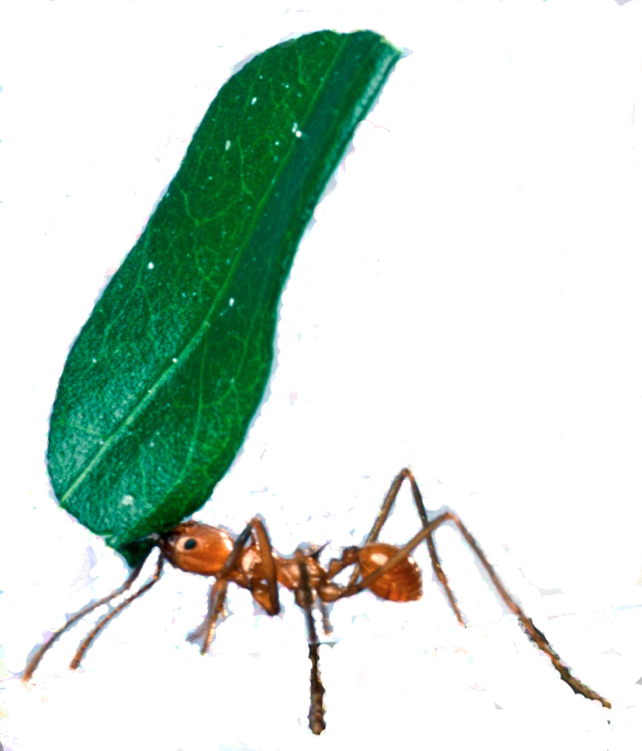
Swarm behaviour and traffic simulations

Using stigmergy to solve algorithmic problems, predict and improve vehicle traffic

JASS 2007
Bernhard Gatzhammer
Computational Science and Engineering
TU München

1. Introduction

Swarms of animals observed in nature give many reasons to be astonished. Despite consisting of many individuals a swarm often gives the impression of being only one single animal, with individuals forming the cells of it. Especially social insects like ants and other types of social insects achieve to manage tasks that far exceed the individuals capabilities. Why not trying to find the key elements behind this highly successful behaviour and transfer it to selected problems of Computer Science and Scientific Computing?

2. Social insects and Stigmergy

The term Stigmergy was originally defined by Grassé, who observed termites behaviour. His definition is as follows: Stigmergy is "stimulation of workers by the performance they have achieved". Workers is referred here to a caste of termites.
Today a more general definition exists that describes Stigmergy as
follows: "Stigmergy is a method of indirect communication in a self-organizing emergent system where its individual parts communicate with each other by modifying their local environment."
In this paper pheromones dissipating over time are regarded to be the
means of stigmergic communication.

3. Ant algorithms and application examples
3.1 Foraging in ants and the Travelling Salesman Problem (TSP)

Foraging is a term from biology and basically means searching for food. Ants are showing the interesting behaviour of finding the shortest way from their nest to a food source. Biologists found out that ants do achieve this by using a trail-laying and trail-following method with pheromones. This behaviour is basically Stigmergy.
Experiments with ants show their ability to find shortest paths. In a set up with two different long paths connecting a ant nest to a food source almost all ants choose the shorter way after some time (see fig.1). This is called "Differential length effect".

Fig. 1: Experimental set up with a two branch bridge. The branches have different lengths. Ants choose the shorter branch. Middle picture after 4 minutes, right picture after 8 minutes. Source [1]

Now looking at the TSP, we have a set of given cities, each connected to each other. The cities have to be visited in a loop of shortest length, whereas each city must only visited once.
Representing this problem by graph theory leads to a more abstract representation with vertices and edges connecting these. Artificial ants can now explore the graph by using the foraging behaviour of ants and a probabilistic transition rule. Artificial pheromones are added after the completion of a tour and influence further ants in choosing their ways. After some time a solution to the TSP can be found.
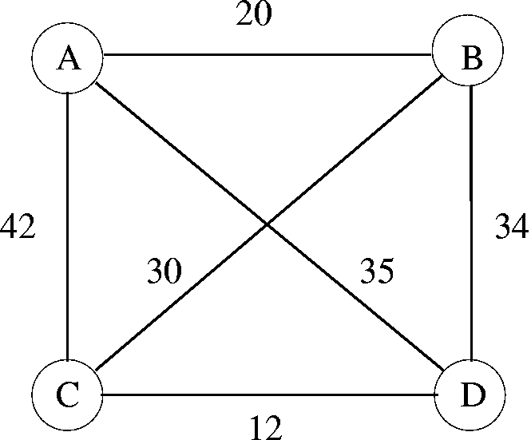

Fig. 2: A graph representing a TSP example. The problem consists of 4 cities A, B, C and D connected to each other by 6 edges. Each edge has assigned a length value that is the length of the path from one city to another. Source [1]

3.2 Labour division among social insects and adaptive task allocation

A fundamental division in social insects is the division of reproductive castes from worker castes. Further divisions are observed in worker, age or morphological sub castes. Finally, also these sub castes can have divisions that can be called behavioural castes. These division may be only temporal.
An important ability shared among social insects is called plasticity. It allows workers to switch tasks in response to internal perturbations or external challenges in order to maintain the colonies viability and reproductive success.

A model of labour division derived from these observations is based on the idea of a response threshold. It describes individuals engaging in tasks, when the task-related response threshold of the individual is exceeded by a stimulus. The stimulus plays the role of Stigmergy here and can be represented by pheromones again.
To get a more realistic model thresholds should be able to vary in time. If a task is performed by an individual the related threshold decreases while all other thresholds are increasing. This process is called reinforcement learning.

This model can be applied to achieve adaptive task allocation. An example shows an express mail company that has to allocate their mailmen to costumers in a given city. The goal is to optimally deal with arising demand. When a demand is arising for each mailman there exists a certain probability p_{ij} to react to it dependant to the following factors:
1. The mailman's response threshold related to the area with the demand.
2. The distance between the current position of the mailman and the area with demand (can also include traffic jams, lights, …).
3. The value of the demand, representing the stimulus to retrieve a mail.

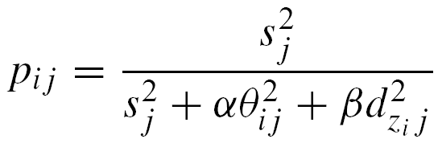

(1)

Formula (1) models the probability for a mailman i located in zone z_{i} to react to a demand from zone j. The stimulus of zone j is represented by s_{j}, the mailman's response threshold to zone j by Ө_{ij} and the distance to zone j by d_{zi j}. α and β adjust the influence of the threshold and the distance on the reacting probability and the power of 2 sets the steepness of the transition from reacting to non-reacting.

4. Traffic simulations

Traffic simulations can be done to achieve the following goals:
1. To predict drivers behaviour in order to adjust dynamic traffic signs, or propose alternative routes in navigation devices or radio.
2. To improve traffic infrastructure and traffic light plans in big, complicated traffic networks like cities

4.1 Traffic simulation by Cellular automata

Two major approaches for simulating traffic flow have been investigated:
1. A fluid-dynamical approach, looking at traffic as continuous fluid.
2. Discretized cellular automata models.

While the first approach is a macroscopic one, the latter, which has the focus here, describes traffic in a discretized microscopic way. Discretized means a street is divided into sites with fixed size, the speed of the cars is an integer value and a site can be either occupied by one car or can be empty.
Assuming a simple one lane model, the following steps have to be performed in every cycle with each car in parallel:
1. Acceleration or slowing down
2. Randomization of speed
3. Car motion
This simple model is already showing realistic and non-trivial behaviour.

4.2 Adopting the stigmergic process

The cellular automaton model is extended by the pheromone dropping and sniffing behaviour of ants. This leads to a very realistic and dynamic model and reduces communication between cars to local information creation and retrieval. Computational costs can be reduced for collision checking. The examination of traffic signs and other environmental signals still needs to be done non-localized. The model could be named "Cellular automata ant model".
In the model, every car is leaving pheromone on the street, depending on the speed with which it is travelling. Faster cars leave longer, more spread out trails, slower cars have shorter trails. For some cases additional pheromone dropping is necessary:
1. When a car has stopped, it would not leave a sufficient long trail behind it. Extra pheromones need to be set.
2. When a car decelerates quickly a similar situation occurs and extra pheromones need to be set.
3. A car changing lanes projects some time before the change heromones to the desired lane and warns other cars by this.
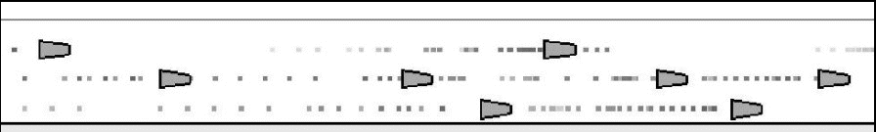
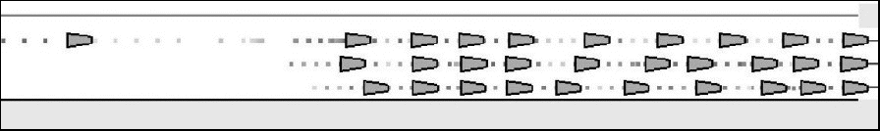
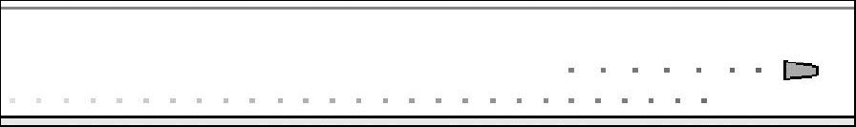

Fig. 3: top: cars with driving with different speeds; middle: cars stopping at a red light; bottom: car projecting pheromones to change lanes . Source [3]

This additional pheromone dropping behaviour can be compared to using signal and brake lights in order to inform other cars in reality.

4.3 Prediction of driver behaviour

Predictions on traffic development allow more effective control of traffic flow. To get information about cars entering or leaving certain areas, measurement devices like cameras have to be installed.
Using swarm approach one can predict slowing down traffic and for example set a speed limit for approaching cars to reduce car density. Growth of traffic jams can be simulated and useful redirections can be given. In case of traffic jams, also the behaviour of leaving the main highway and taking alternative routes can be predicted by using the foraging behaviour of ants (cars likely follow other cars via pheromone trails). Doing so, more efficient alternative routes can be found by spreading cars onto several routes (e.g. via navigation device).

4.4 Optimizing traffic light plans

Optimizing traffic light plans reduces waiting times for cars and therefore also reduces pollution, stress and its possible consequences. Here the focus is on two different approaches, whereas both have a microscopic traffic model as basis.

4.4.1 Cars voting for traffic lights

The first approach treats pheromone leaving cars as the main agents. While a car is heading to its destination it keeps track of two variables, the total driving time d^{tot} and the total waiting time w^{tot}. From this a waiting measure σ_{i} can be calculated for each car i.
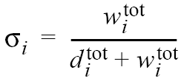

(2)

After some time of simulation an overall waiting measure ∆_{wait} gives information about the success of the applied lighting plans.
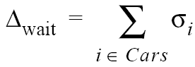
(3)

In order to improve the lighting plan timing an evolutionary strategy is applied. The timing sequences of lights are mutated after each simulation cycle. In order to mutate the light plans with deficiencies, cars that are stopped by a red light during their journey give a vote to that light. The lights with most votes are most probable to be mutated.
A mutation creates several childs of a light plan. Every child has to be simulated in a different simulation and can then be evaluated through the overall waiting measure. The plan with least waiting measure will survive. After some generations of light plans real improvements can be found.
One design environment comprising all this features is called SuRJE. It allows to interactively build 2D road maps with multi lane roads, define car seeding areas and enables to set initial light timing parameters. Details about the evolutionary strategy, like the number of mutations per generation, can also be adjusted. When running a simulation, cars are visualized and realistic behaviour can be observed. The simulation results can be applied to road networks with older lights, which light plans are just pre-programmed and cannot be changed dynamically.

4.4.2 Traffic lights as social insects

In the second approach to improve traffic light timings, intersections with lights are treated as social insects. Every insect has to perform one light plan out of several available. The traffic itself does not need to be simulated by a swarm based approach, any microscopic model is sufficient. Stimuli for the insects is provided by cars waiting or crossing an intersection. There pheromones are left again.
To achieve a good choice of light plans the adaptive task allocation model introduced in chapter 3.2 is used again. Each social insect has response thresholds to each available traffic light plan. A plan j is chosen, when the stimulus s_{j} provided by pheromones exceeds a threshold. Equation (4) models the stimulus for a light plan j.
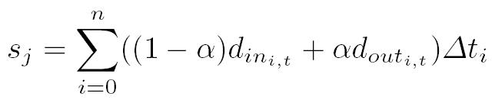

(4)

i : phase number of plan j
n : number of phases in plan j
d_{in} : pheromone density in incoming lanes of phase i
d_{out} : pheromone density in outgoing lanes of phase i
∆t_{i} : ratio of length of phase i over length of one total cycle in plan j
α : determines influence of incoming lanes and outgoing lanes

Reinforcement learning with thresholds varying in time is used to specialize intersections. Formula (5) shows the thresholds dependency on learning factor l. l is positive if a plan is run successfully and negative if not.
(5)

Formula (6) shows how the learning factor l can be calculated, with σ being the standard deviation of pheromone densities in in- and outgoing lanes of the intersection.
(6)

The adaptive task model can be directly applied to road networks with modern light system having sensors to count in- and outgoing cars (e.g. inductive coils).

5. List of applications for swarm based approaches

- Scheduling Problems (e.g. subway, train)
- Vehicle Routing (e.g. bus, taxi)
- Connection-oriented network routing (e.g. internet, TCP/IP)
- Connection-less network routing (e.g. Bluetooth, infrared)
- Optical networks routing

References

[1] Marco Dorigo, Eric Bonabeau, Guy Theraulaz, Ant algorithms and stigmergy, Future Generation Computer Systems 16 (2000) 851 – 871

[2] Kai Nagel, Michael Schreckenberg, A cellular automaton model for freeway traffic, J. Phys. I France 2 (1992) 2221 – 2229

[3] Ricardo Hoar, Joanne Penner, Cristian Jacob, Evolutionary Swarm Traffic, If Ant Roads Had Traffic Lights, Proceedings of the 2002 Congress on Evolutionary Computation, vol. 2, pages 1910 – 1915 2002

[4] Denise de Olivera, Paulo Roberto Ferreira Jr., Ana L. C. Bazzan, Franziska Klügl, Reducing Traffic Jams with a Swarm-based Approach for Selection of Signal Plans, Proceedings of Fourth International Workshop on Ant Colony Optimization and Swarm Intelligence – ANTS 2004, vol. 3172 of LNCS 2004

